<https://radacad.com/dynamic-row-level-security-with-organizational-hierarchy-power-bi>

<https://www.kasperonbi.com/power-bi-desktop-dynamic-security-cheat-sheet/>

[samAccountName vs userPrincipalName - MorganTechSpace](https://morgantechspace.com/2014/04/samaccountname-vs-userprincipalname.html)

[samAccountName Vs userPrincipalName (faqforge.com)](https://www.faqforge.com/windows/samaccountname-vs-userprincipalname/)

<https://qnrl.sharepoint.com/sites/StudyGroup/Shared%20Documents/Power%20BI/Row%20Level%20Security/organizational-hierarchy-Data.xlsx>

Document - RLS

Simple example

Filter - on client table

Heirachy set up

Filter based pathcontains

related to all facts as a conformed dimension otherwise will not work as expected

Assets - so can only see certain records - "filter out white noise to see usable data"

Engineers can only see certain records

Usability rather than security

BSMCLAD2@business-stream.co.uk

MASSONDA@business-stream.co.uk

BSONEIN1@business-stream.co.uk

BSBEITK1@business-stream.co.uk

BSBARRY1@business-stream.co.uk

BSHOODK1@business-stream.co.uk

BSARSOM1@business-stream.co.uk

https://app.powerbi.com/groups/47ecaa86-914d-4d64-a661-44f7e81d2dd3/list?ctid=18732306-2590-469d-bcc1-77318603beff

https://radacad.com/dynamic-row-level-security-with-organizational-hierarchy-power-bi

<https://www.kasperonbi.com/power-bi-desktop-dynamic-security-cheat-sheet/>

Row level security - RLS

Purpose

A report has been created which meets all the requirements of the customer. Now the customer wants to show only a certain part of the dataset to certain people. An example of this is the Sales Team manager wants to see all records for their team. When the individual members of the team log in and view the report they only see their own records.

This is the example what is going to be built is a very simple model. With two dimensions connected to single fact table.

In the screenshot below, this was the POC we created for a customer. The central fact table records when a Personal Assistant is visiting a Supported person. When a supported person logs into the Power BI service using their email address. Using RLS then only the records for the supported person will be displayed.

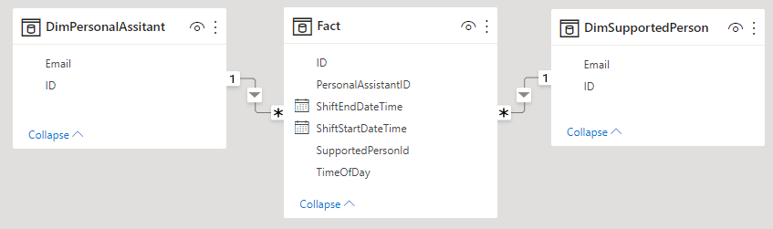Crea

**DimSupportedPerson – Table**

This has two fields

**ID** – Primary key which links to the Fact Table field PersonalAssistantID

**Email** – Text filed containing the email address of the supported person

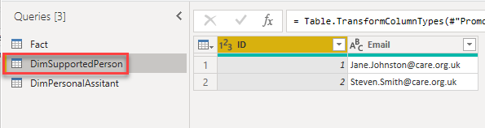

**Fact – Table**

**ID** – Primary key

**PersonalAssistantID** – this is the foreign key to DimSupportedPerson.ID This has a many to one relationship with DimSupportedPerson

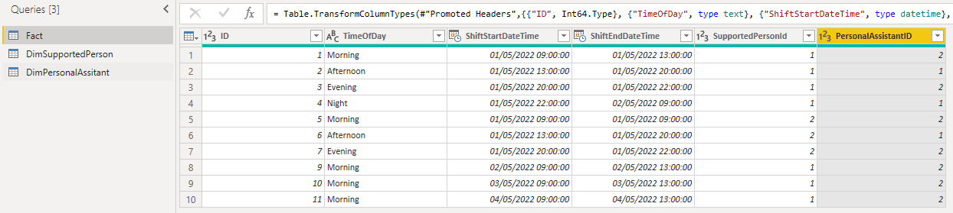

**Set up RLS in Power BI Desktop**

Create role, in Power BI desktop ensure, select ‘Modeling’ in the main menu, then find ‘Manage roles’.

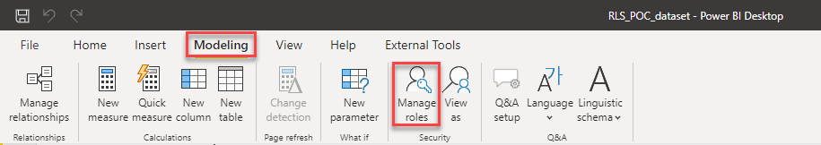

When the new window opens then, click on the ‘Create’ button.

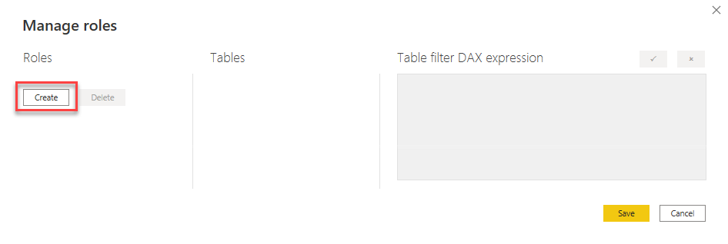Next step is to add a new role for Row Level Security.

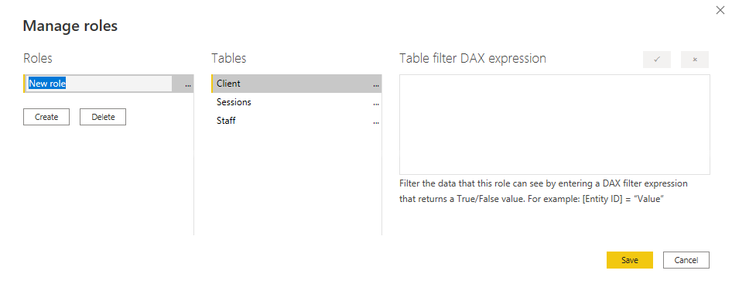In the example below the role added is ’ClientEmail’. Next step is to add the filter, to the appropriate table. The filter has been added ’Client’ table, then click on ’Add filter...’ In the example the [Email] field will have a filter added to it.

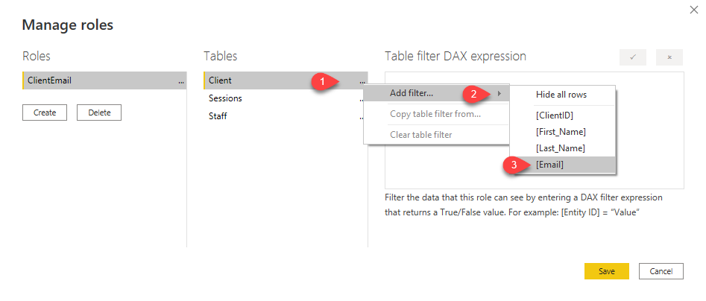The filter will be added automatically which you can see in the screenshot below.

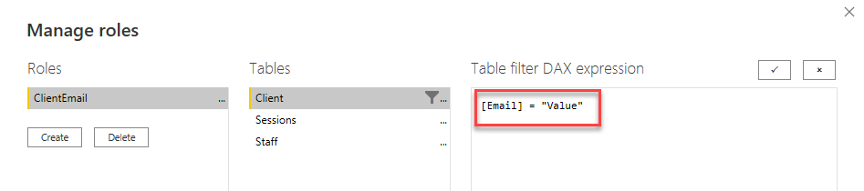This is not the DAX expression that will be used for filtering the client table. The DAX expression that is going to be used is in the screenshot below.

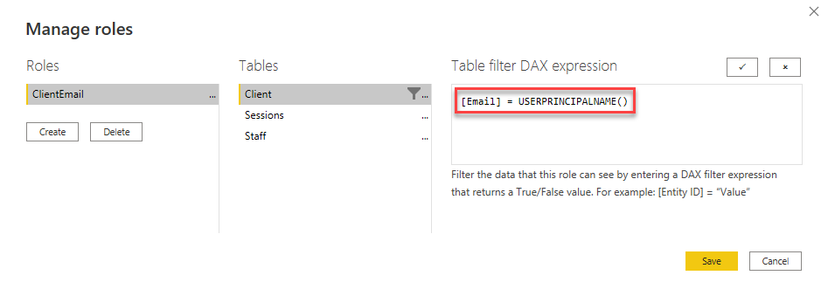The DAX function USERPRINCIPALNAME () will return the email address of the person which is logged into the Power BI service and viewing the report. This email address in turn will be used to filter the Dimension Table. Only rows where the email address matches the one returned by the function USERPRINCIPALNAME () will be returned from the table Client.

The screenshot below show the relationship between tables in the Power BI desktop report.

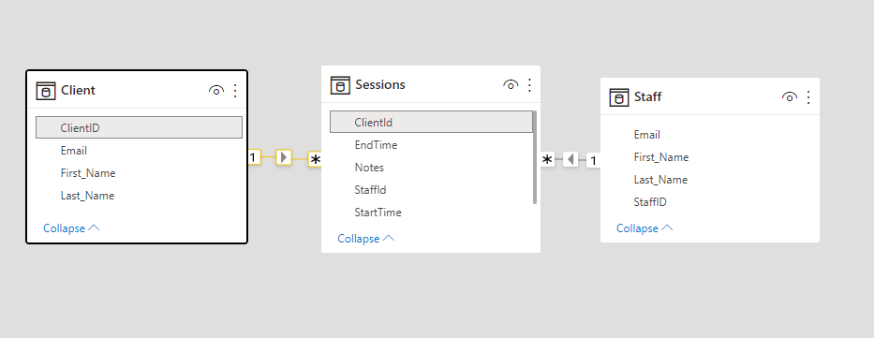

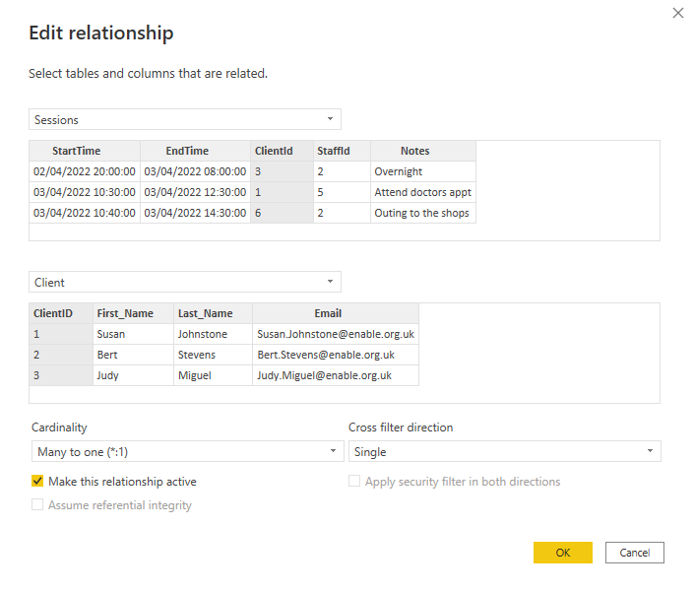

Note that the Client table has a one to many relationship with Sessions, so when filter the client table. The corresponding records will in the sessions table will be filtered.

------------------------------------------------------------------------------------------------------------------------------------

Once relationships are in place as required and the expression has been added to the dimension table which going to filter on. At this point it is possible to test and see if the row level security works as expected. In the screenshot below the Sessions table is shown.

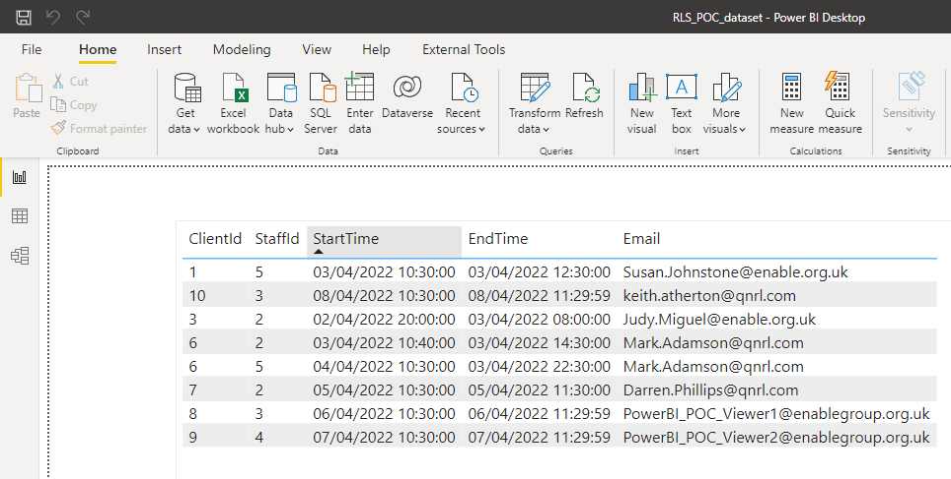

This shows all the records in the table since no row level security has been applied. Since the account has created this report can see all the records. To see how this table would look if applied row level security and viewing the table as the email address [‘PowerBI_POC_Viewer2@enablegroup.org.uk’.](mailto:‘PowerBI_POC_Viewer2@enablegroup.org.uk’) This can be done by going to the top menu and selecting ‘Modeling’, then click on ‘View as’ from the menu.

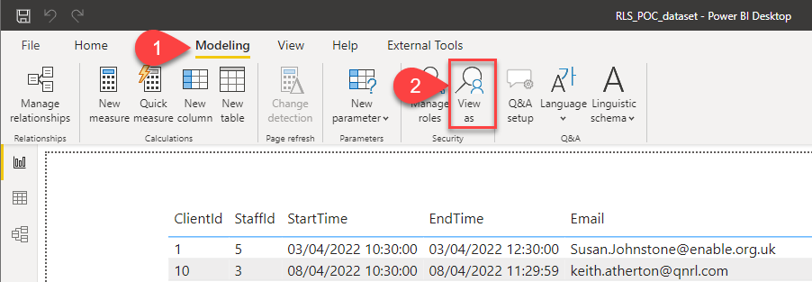

When the window opens, the roles will be listed in this example there is only one role ‘ClientEmail’

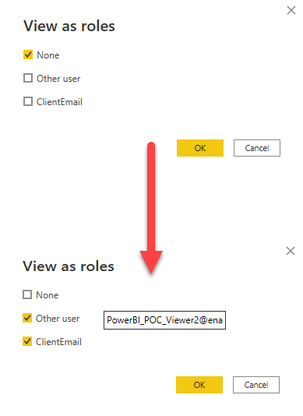

First step is to deselect the ‘ None’ tick box. Select the other two tick boxes eg ‘Other user’ and ‘ClientEmail’. The ‘Other user’ box will be empty enter the email address that want to view the report as. In this case the email address is [‘PowerBI_POC_Viewer2@enablegroup.org.uk’.](mailto:‘PowerBI_POC_Viewer2@enablegroup.org.uk’) Once the email address has been entered, then click on the ‘OK’ button to view the report as that user would see the report.

